**TASK 1:- SELECT STATEMENTS**

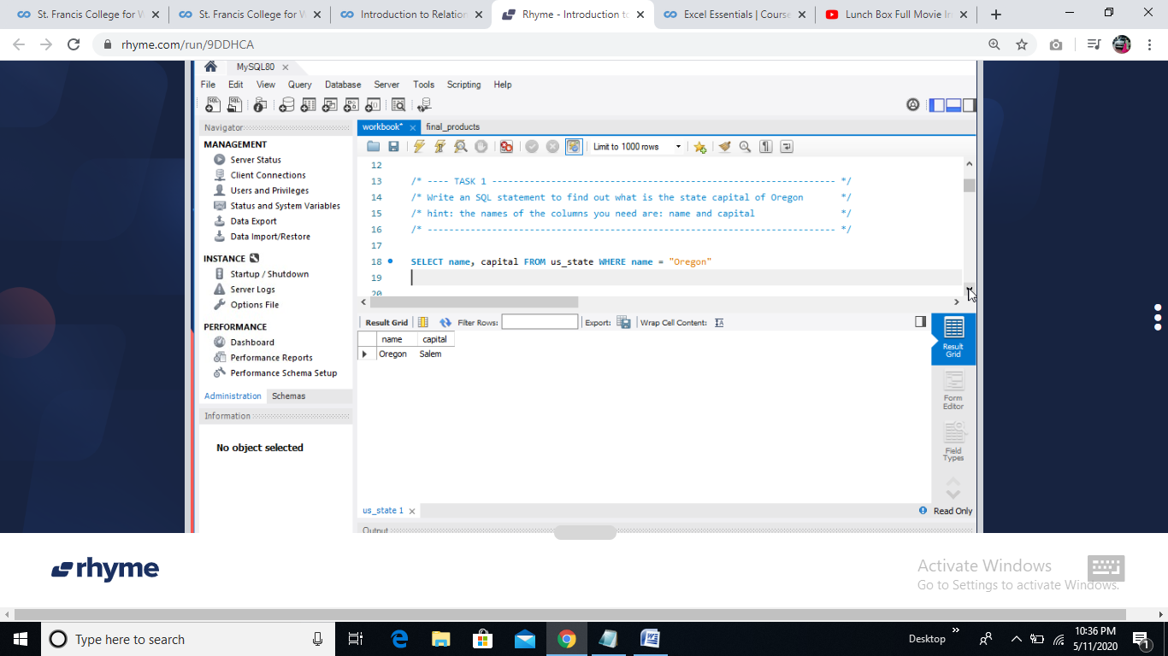

**TASK 2:- SELECT STATEMENTS WITH PATTERN MATCHING AND SORTING**

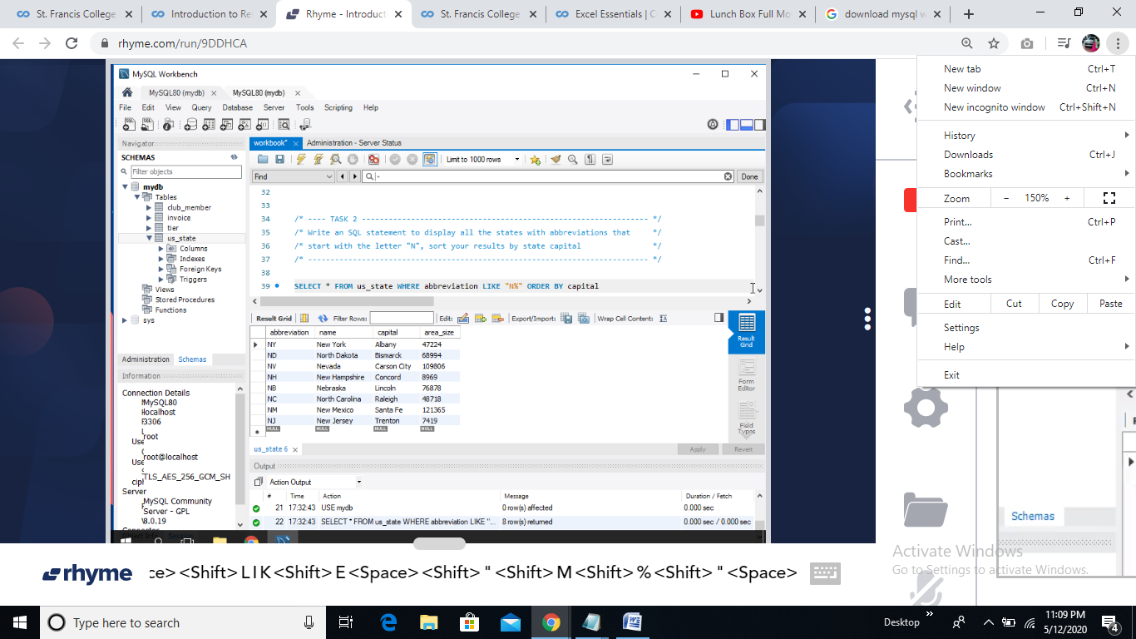

**TASK 3:- INSERT STATEMENTS**

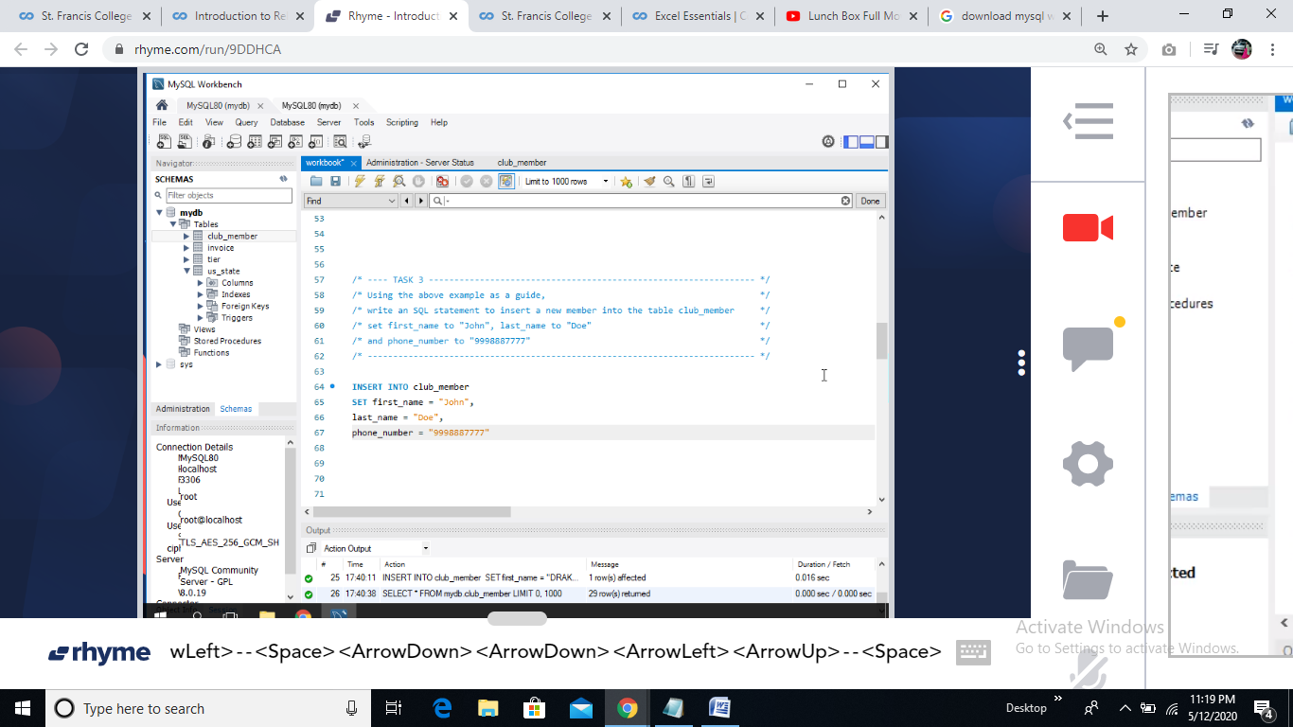

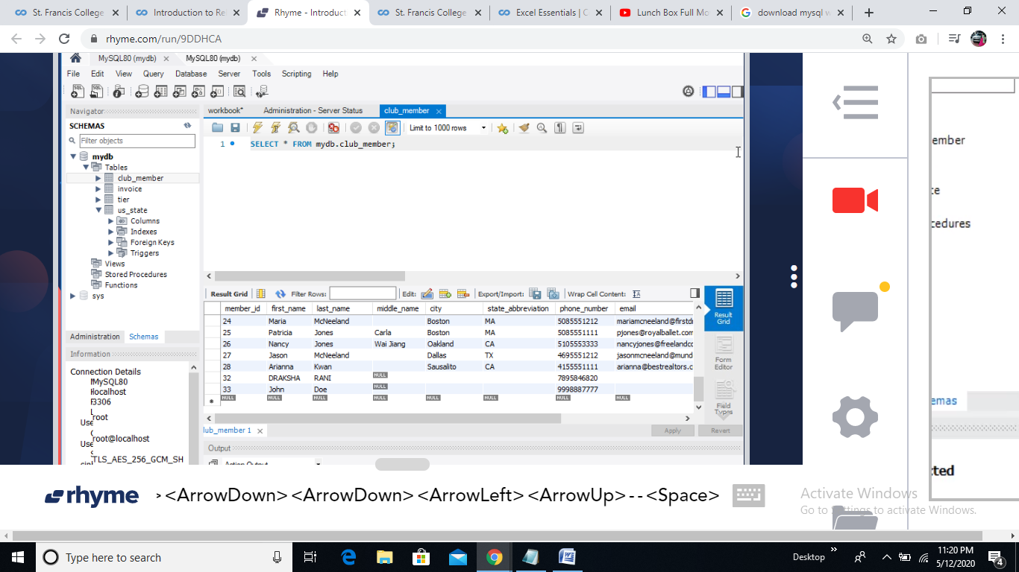

**TASK 4:- DELETE STATEMENTS (deleted data inserted in TASK 3)**

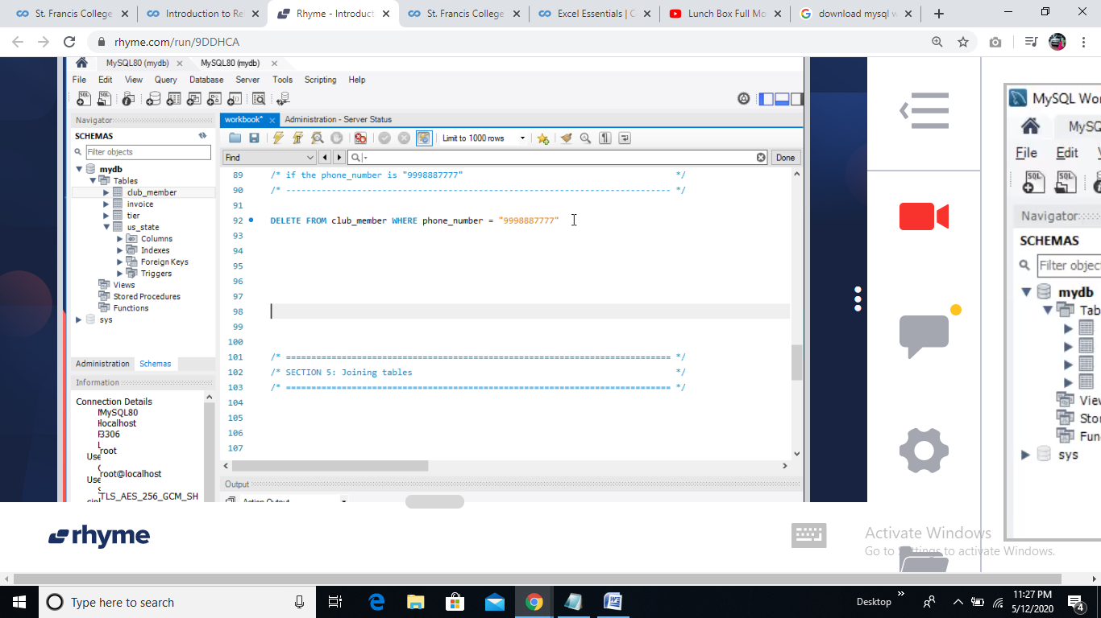

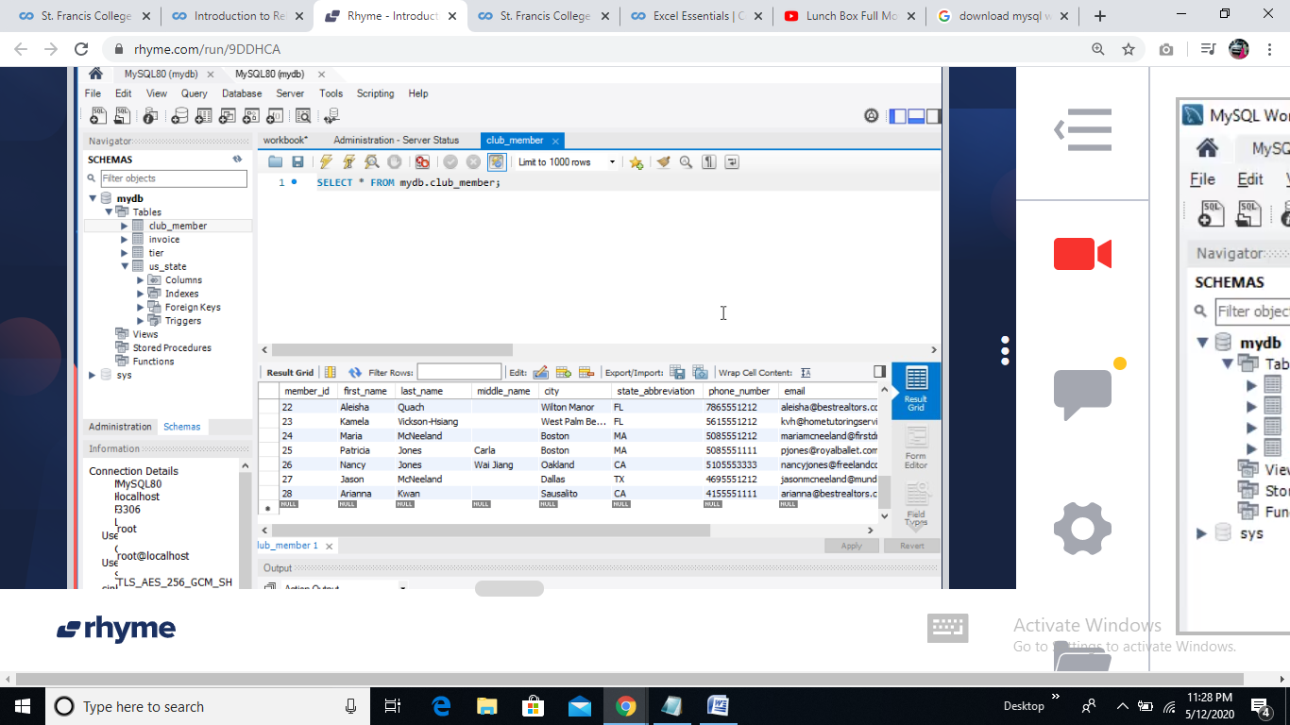

**TASK 5:- JOINING TABLES**

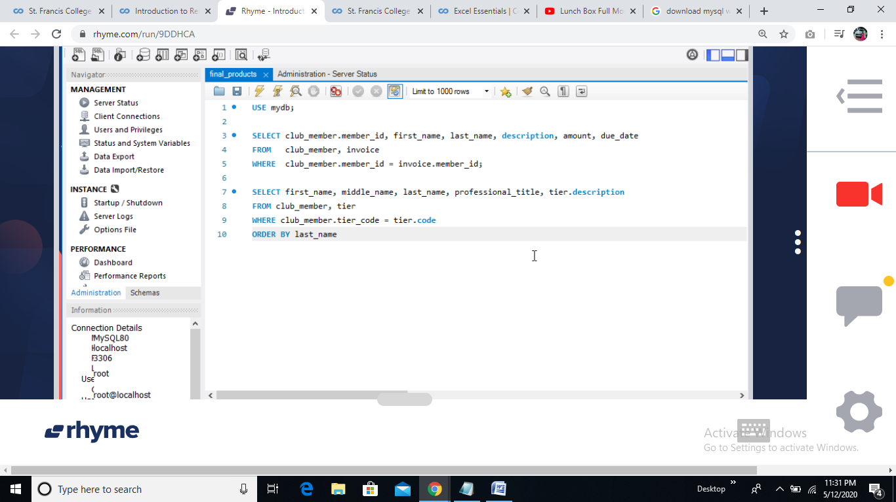

*Couldn’t show screenshots of TASK 5(As the course had a timer for usage of cloud and I didn’t happen to notice)*

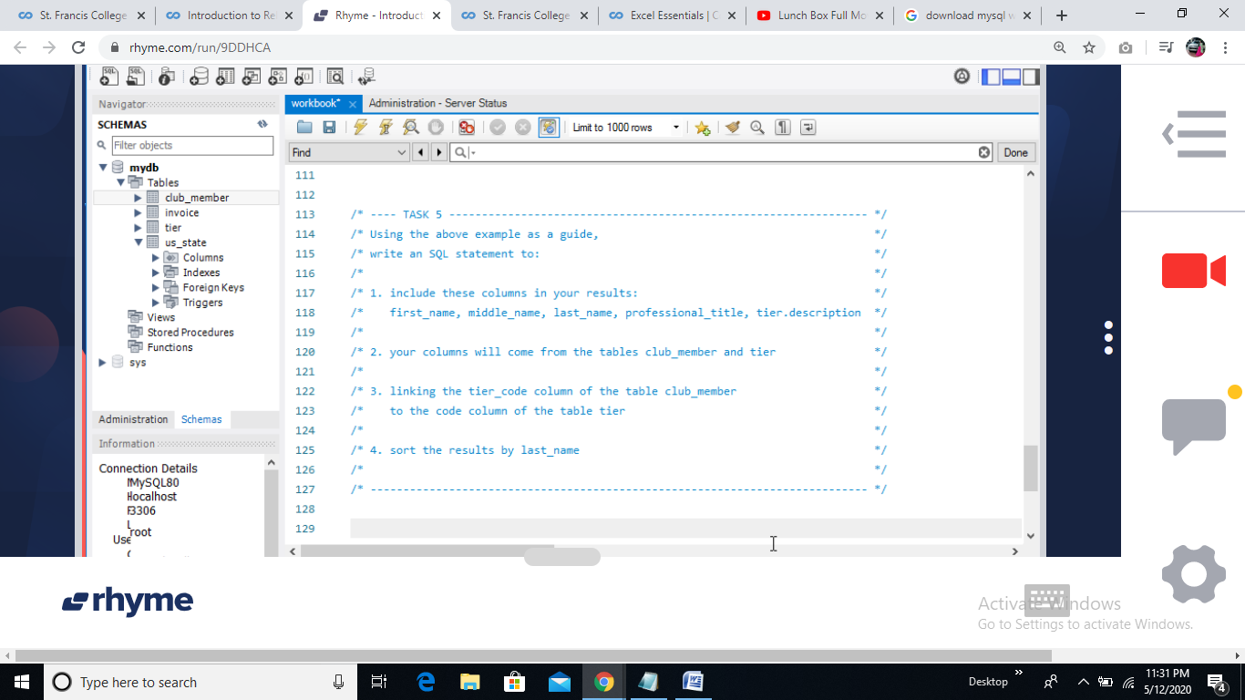

*SYNTAX:-*

SELECT first_name, middle_name, last_name, professional_title, tier.description

FROM club_member, tier

WHERE tier_code = code(I think the 3rd point in question is wrong)

ORDER BY last_name